# Exercises: Git Branching and Pull Requests

Problems for exercises for the "[Software Engineering and DevOps](https://softuni.bg/trainings/4333/software-engineering-and-devops-october-2023)" course @ SoftUni.

**Note that for this exercise you should have a GitHub account.**

## The "Towns" Project

The **"Towns" project** provides a simple HTML and JavaScript based Web front-end interface to **view**, **add**, **delete** and **shuffle** a **list of towns**. The project is **unfinished**, so some of the **functionality is** **already implemented** (view and delete) and **other functionality is** **to be implemented** (add and shuffle towns + CSS styling). This is how the "Towns" project looks like at the beginning:

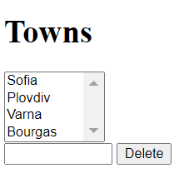

At the start, in the GitHub repo you will have **3 source code files**: **towns.html** + **towns.css** + **towns.js**, and a **README.md** documentation file:

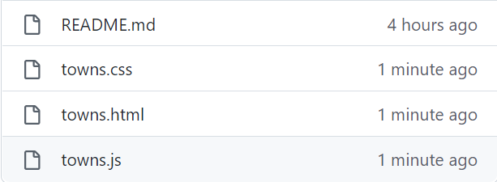

### Roles Assignments

Your task is to **work in teams of 3 students or work alone with several roles to simulate multi-user interaction**, where each role follows the instructions for certain team member – **Editor**, **Shuffler** and **Styler**.

If you work in a **team of 3 students**, one of you should also take the role of the **Team Leader**.

If you work **alone**, you should work with a **fourth** role – the **Team Leader**.

#### Editor

The Editor should implement "**add new town**" functionality:

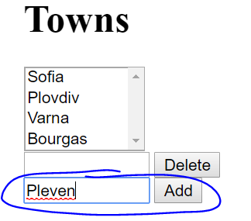 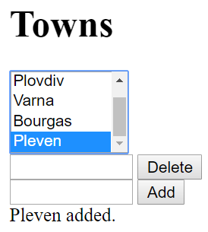

#### Shuffler

The **Shuffler** should implement "**shuffle towns**" functionality.

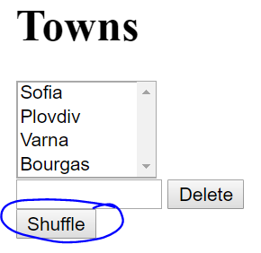 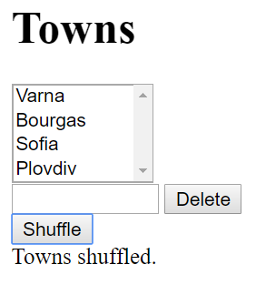

#### Styler

The **Styler** should add some **CSS styling** and **improve** the **HTML UI**.

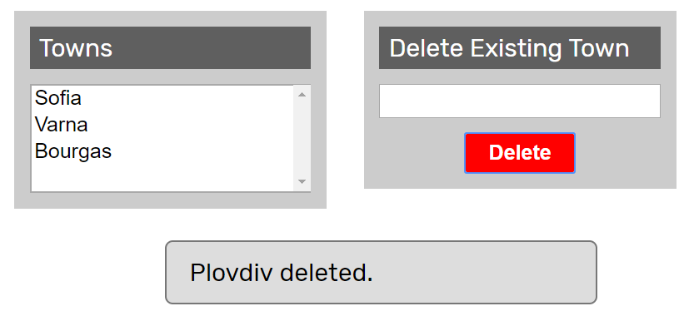

### Fork the Repo

The **team leader** does the following:

Fork the "**Towns**" repo from GitHub: [**https://github.com/SUContent/Towns**](https://github.com/SUContent/Towns)

### Invite the Team Members

The **team leader** invites the **other team members** as **collaborators** in the new GitHub repo.

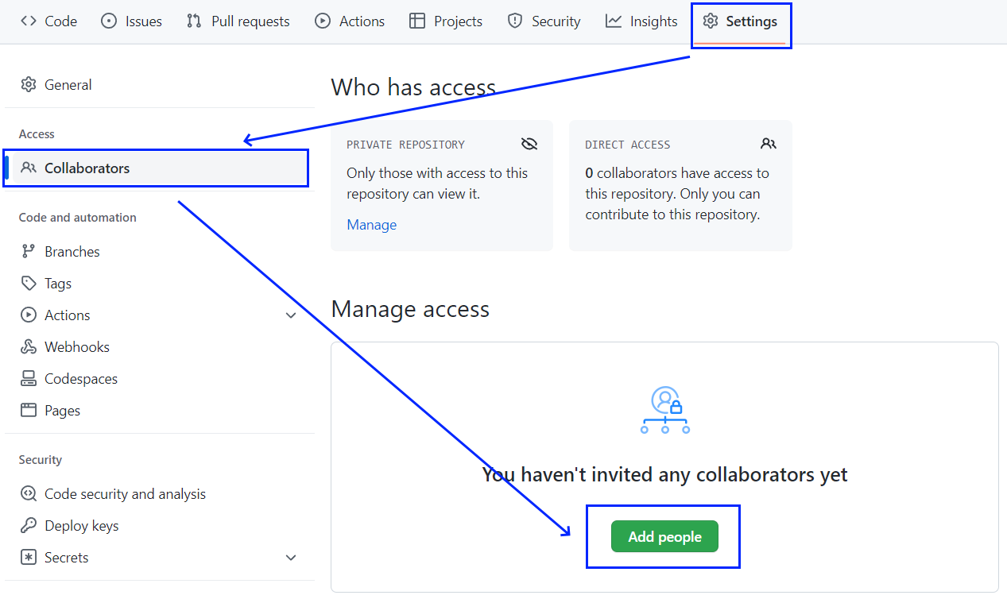

* An **email** **invitation** will be sent for each **invited** **collaborator**.

### Team Members Should Clone the Project

**Each team member clones** the project from the **team** **leader's GitHub repository**:

|  |
| --- |
| **git clone https://github.com/<team-leader-username>/Towns** |

### Edit the Project Description

This step should be executed only **after each team member have already cloned the project** locally.

The **team** **leader** makes **changes** in **README.md** file from the GitHub's project Web site, to describe with a text which team member which role will take, e.g.,

**# Roles**

* **{Name1} takes the role "Editor"**
* **{Name2} takes the role "Shuffler"**
* **{Name3} takes the role "Styler"**

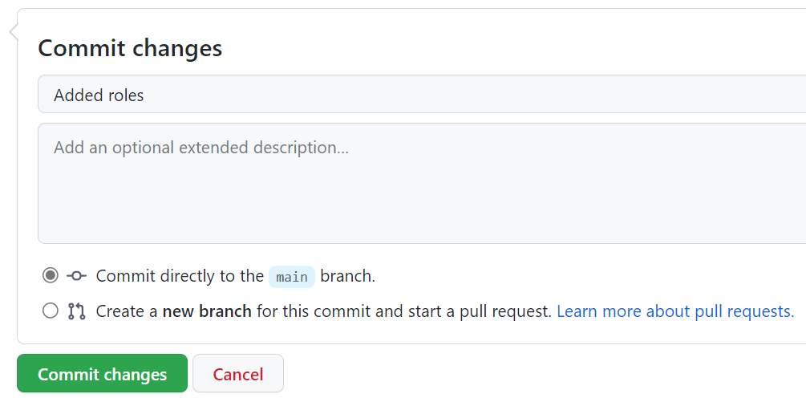

### Implement Project Functionalities

Each **team** **member** **implements** different **functionality locally** (each **member** has its **own instructions**).

* **Member #1**: **Editor**'s functionality (**add town**)
* **Member #2**: **Shuffler**'s functionality (**shuffle towns**)
* **Member #3**: **Styler**'s functionality (**improve styling and CSS**)

**NOTE:** If you are working alone, don't forget that you should fulfil the three roles **simultaneously**.

#### Editor

The **Editor** should already have cloned the forked repo.

##### Step 1: New Town Textbox + Button

Now, in towns.html, the editor should add a textbox + button for creating a new town:

|  |
| --- |
| <div>  <input type="text" id="townNameForAdd" />  <button id="btnAdd">Add</button>  **</div>** |

##### Step 2: New Town JavaScript Code

In towns.js, the editor has to add a new function for adding a new town:

|  |
| --- |
| function addTown() {  let townName = $('#townNameForAdd').val();  $('#townNameForAdd').val('');  $('#towns').append($('<option>').text(townName));  $('#result').text(townName + " added.");  **}** |

Also, the editor should add a code to **attach an event handler** to invoke the new function when the **[Add]** button is pressed. In the start of the JS code, he adds the code marked in **blue** below:

|  |
| --- |
| $(document).ready(function() {  …  $('#btnAdd').click(addTown);  **});** |

##### Step 3: Test the Project functionality

**Editor** now should **test the project functionality** to see whether the styling and effects work correctly, as well as whether the entire project works as expected:

 

##### Step 4: Commit All Changes in the Local Repo

**Editor** **adds** and **commits** in Git all local changes:

|  |
| --- |
| **git commit -a -m "Implemented functionality to add a new town"** |

##### Step 5: Push the Local Commits to GitHub

**Editor** pushes all the changes to Git:

|  |
| --- |
| **git push** |

##### Step 6: Resolve Any Conflicts

|  |
| --- |
| **git pull** |

**Editor** **should edit** **all** **files** and **fixes** the code in order to **merge** all concurrent **changes** **correctly**.

Then, Editor **adds** and **commits** in **Git** the **merged** **files**:

|  |
| --- |
| **git commit -a -m "Implemented functionality to add a new town + merged the conflicting files"** |

Finally, **Editor should push all his changes** again to Git:

|  |
| --- |
| **git push** |

#### Shuffler

The **Shuffler** should already have cloned the forked repo.

##### Step 1: New Town Textbox + Button

Now, in towns.html, the editor should add a textbox + button for shuffling the towns:

|  |
| --- |
| <div>  <button id="btnShuffle">Shuffle</button>  **</div>** |

##### Step 2: New Town JavaScript Code

In towns.js, the editor has to add a new function for shuffling the towns:

|  |
| --- |
| function shuffleTowns() {  let towns = $('#towns option').toArray();  $('#towns').empty();  shuffleArray(towns);  $('#towns').append(towns);  $('#result').text("Towns shuffled.");  function shuffleArray(array) {  for (var i = array.length - 1; i > 0; i--) {  var j = Math.floor(Math.random() * (i + 1));  var oldElement = array[i];  array[i] = array[j];  array[j] = oldElement;  }  }  **}** |

Also, the editor should add a code to **attach an event handler** to invoke the new function when the **[Add]** button is pressed. In the start of the JS code, he adds the code marked in **blue** below:

|  |
| --- |
| $(document).ready(function() {  $('#btnShuffle').click(shuffleTowns);  **});** |

##### Step 3: Test the Project functionality

**Shuffler** now should **test the project functionality** to see whether the styling and effects work correctly, as well as whether the entire project works as expected:

 

##### Step 4: Commit All Changes in the Local Repo

**Shuffler** **adds** and **commits** in Git all local changes:

|  |
| --- |
| **git commit -a -m "Implemented functionality to shuffle the existing towns"** |

##### Step 5: Push the Local Commits to GitHub

**Shuffler** pushes all the changes to Git:

|  |
| --- |
| **git push** |

##### Step 6: Resolve Any Conflicts

|  |
| --- |
| **git pull** |

**Editor** **should edit** **all** **files** and **fixes** the code in order to **merge** all concurrent **changes** **correctly**.

Then, **Shuffler** **adds** and **commits** in **Git** the **merged** **files**:

|  |
| --- |
| **git commit -a -m "Implemented functionality to shuffle the existing towns + merged the conflicting files"** |

Finally, **Shuffler should push all his changes** again to Git:

|  |
| --- |
| **git push** |

#### Styler

The **Styler** should already have cloned the forked repo.

##### Step 1: Improve the HTML Structure

**Styler** wants to style the site to look better but the **HTML structure** does not allow writing CSS, so they modifie towns.html and introduces a new way to structure the content as a sequence of **articles** holding **headers** and other elements after the header:

|  |
| --- |
| <article>  <header>Towns</header>  <select id="towns" size="4">  <option>Sofia</option>  <option>Plovdiv</option>  <option>Varna</option>  <option>Bourgas</option>  </select>  </article>    <article>  <header>Delete Existing Town</header>  <input type="text" id="townName" />  <button id="btnDelete">Delete</button>  **</article>** |

##### Step 2: Write the CSS Code

**Styler** now rewrites the entire towns.css file from scratch:

|  |
| --- |
| @import url('https://fonts.googleapis.com/css?family=Rubik');  body {  font-family: 'Rubik', sans-serif;  }  * {  box-sizing: content-box;  }  article {  background: #CCC;  width: 180px;  padding: 10px;  margin: 10px;  display: inline-block;  vertical-align: top;  }  article>header {  background: #5F5F5F;  color: white;  margin: 0px 0px 10px 0px;  padding: 4px 6px;  }  article>header>h1 {  margin: 0px;  }  article>select {  width: 178px;  }  article>input {  width: 176px;  }  article>button {  display: block;  margin: 10px auto 0px auto;  border: none;  border-radius: 3px;  padding: 5px 15px;  background: green;  color: white;  font-weight: bold;  }  article>button:hover {  box-shadow: 0px 0px 10px white;  cursor: pointer;  }  button#btnDelete {  background: red;  }  #result {  display: none;  width: 50%;  margin: 10px auto;  padding: 10px 15px;  background: #DDD;  border-radius: 5px;  border: 1px solid #777;  **}** |

The new CSS code assumes the HTML uses **articles** with **headers** for its major areas. It displays the articles in a nice-looking way. The CSS also hides by default the result info box and assumes it will be shown by the JS code later.

##### Step 3: Add "Auto Hide" Effect for the Info Messages

After a button is clicked (e.g. **[Delete]**), the result of the performed action is shown into an info box (**#result**). Styler modifies this behavior, so that the info box is by default hidden, then it displays a message for 3 seconds, then it disappears. First, he adds a JS library in towns.html to enable animation effects with jQuery:

|  |
| --- |
| **<script src="http://ajax.googleapis.com/ajax/libs/jqueryui/1.8.5/jquery-ui.min.js"></script>** |

Next, he modifies the deleteTown() function in **towns.js** to display messages through a new function showMessage(msg):

|  |
| --- |
| function deleteTown() {  let townName = $('#townName').val();  $('#townName').val('');  let removed = false;  for (let option of $('#towns option')) {  if (option.textContent == townName) {  removed = true;  option.remove();  }  }  if (removed)  showMessage(townName + " deleted.");  else  showMessage(townName + " not found.");  **}**  function showMessage(msg) {  $('#result').text(msg).css("display", "block");  setTimeout(function () {  $('#result').hide('blind', {}, 500);  }, 3000);  } |

##### Step 4: Test the Project Functionality

**Styler** now **tests the project functionality** to see whether the styling and effects work correctly, as well as whether the entire project works as expected:



##### Step 5: Commit All Changes in the Local Repo

**Styler adds** and **commits** in Git all local changes:

|  |
| --- |
| **git commit -a -m "Implemented functionality to add a new town"** |

##### Step 6: Push the Local Commits to GitHub

**Styler** pushes all his changes to Git:

|  |
| --- |
| **git push** |

##### Step 7: Resolve Any Conflicts

In case of **conflict** Styler **pulls**, **merges**, then **pushes** again:

|  |
| --- |
| git pull |

**Styler** edits all files and fixes the code in order to merge all concurrent changes correctly.

Then, **Styler adds** and **commits in Git** the **merged files**:

|  |
| --- |
| git commit -a -m "Improved the UI: added CSS styles + HTML structure + JS effects" |

Finally, **Styler pushes all his changes** again to Git:

|  |
| --- |
| git push |

## The "Hotel Reservation" Project

### Create and Clone Repo

The **project "Hotel Reservation"** provides a simple HTML and JavaScript based Web front-end interface to **create a reservation to family hotel**. The project is **unfinished**, so some of the **functionalities are** **already implemented** ("**Thank you" page**) and **other functionalities are** **to be implemented** (Search Form, Search Result Form, Guest Details Form, Confirm Page). This is how the "Hotel Reservation" project looks like at the beginning:

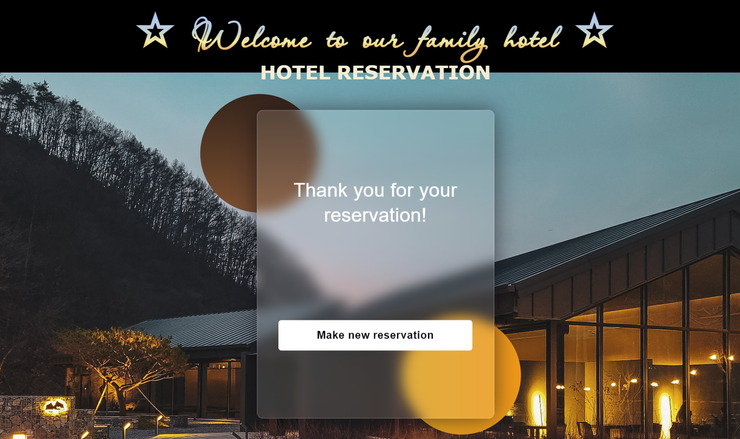

In the beginning you should create an **empty** **GitHub** **repo** and add the files from resources (**index**.**html**, **solution**.**js**, **static** **folder**).

### Team Assignment – Overview

**NOTE: You can work in in teams of 4 students or work alone with several roles to simulate multi-user interaction, where each role follows the provided instructions for the given team member.**

Each team member **chooses a role**:

* **Member #1**: takes the role of **Questioner**.
* **Member #2**: takes the role of **Offerer**.
* **Member #3**: takes the role of **Admin**.
* **Member #4**: takes the role of **Verifier**.

One of the team members takes an additional role: **team leader**.

**Questioner** should implement the "**Search Form**" functionality. This feature will allow the inquirer to **provide** and **manage** offers through a **special** **form** for **date** and **number** of **people**. The provider should include this **functionality** in their **application** to **improve** the **user** **experience**.

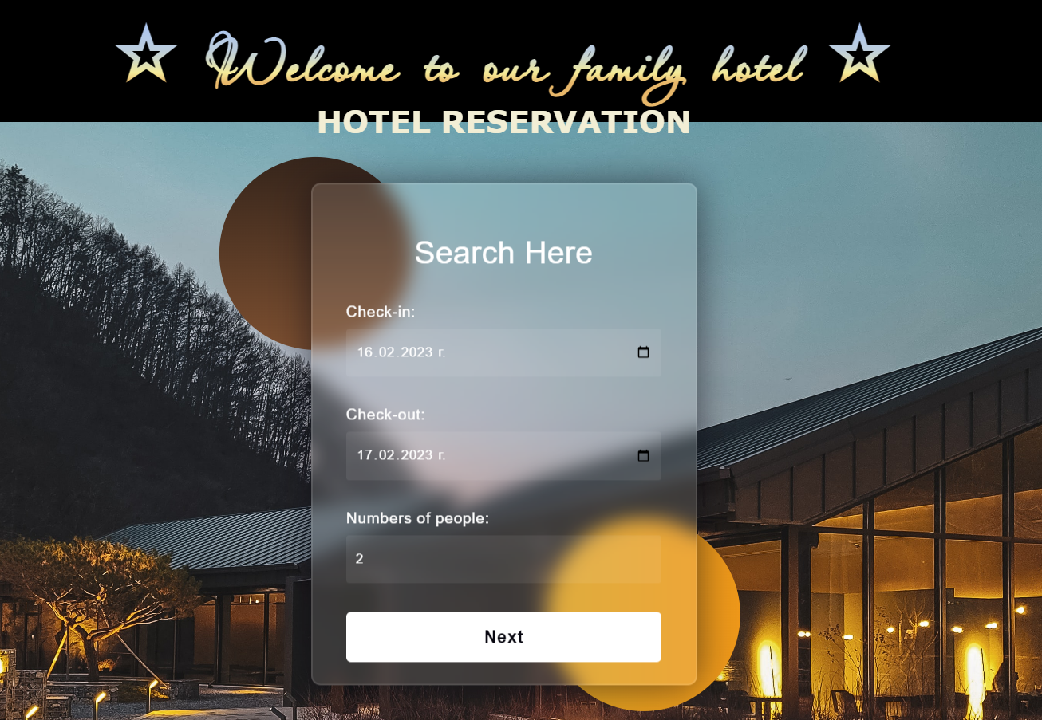

**Offerer** should implement the "**Our Offers Form**" functionality. This feature will enable the Offerer to provide and manage offers through a dedicated form. **Offerer** should **incorporate** this **functionality** into their **application** to **enhance** the **user** **experience**.

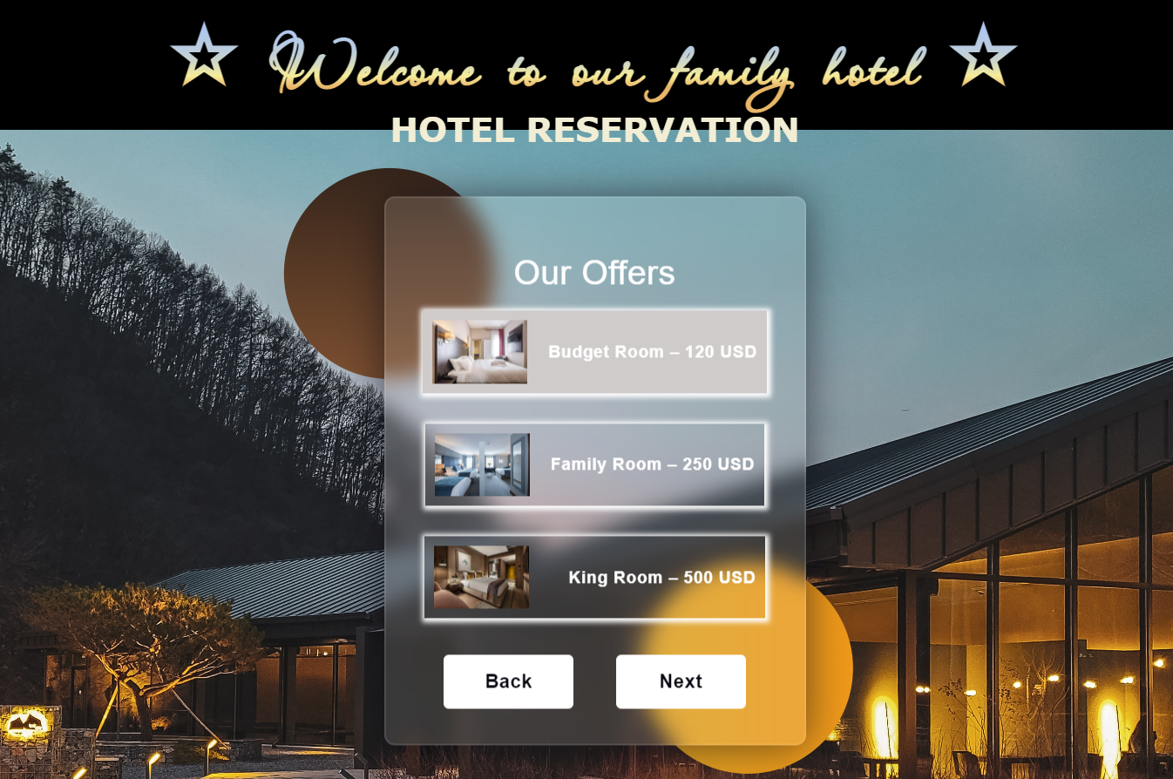

**Admin** should implement the "**Guest Details Form**" functionality. This feature will allow him to gather and manage guest information through a dedicated form. **Admin** should **incorporate** this **functionality** into their **application** to **efficiently** **collect** and **handle** **guest** **details**.

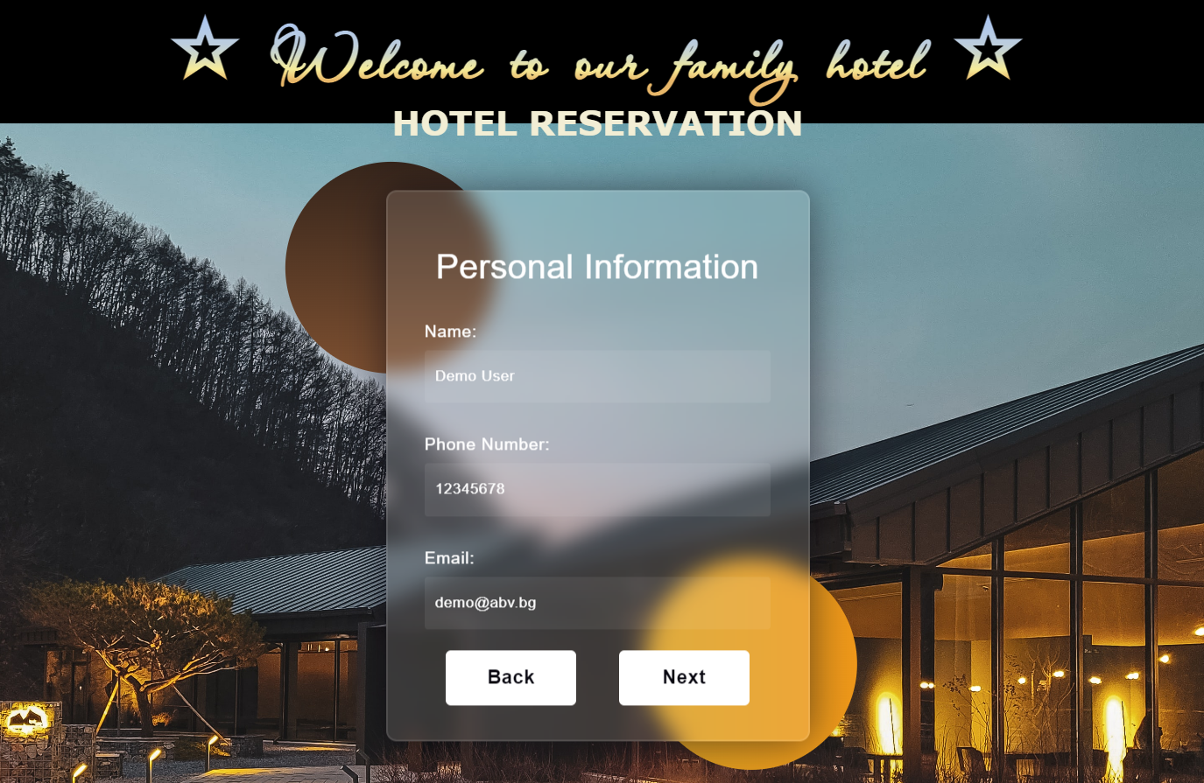

**Verifier** should implement "**Confirm Reservation Form**" functionality. This feature will enable him to confirm reservations through a dedicated form. **Verifier** should **incorporate** this **functionality** into **their** **system** to **efficiently** **handle** and **validate** **reservation** **requests**.

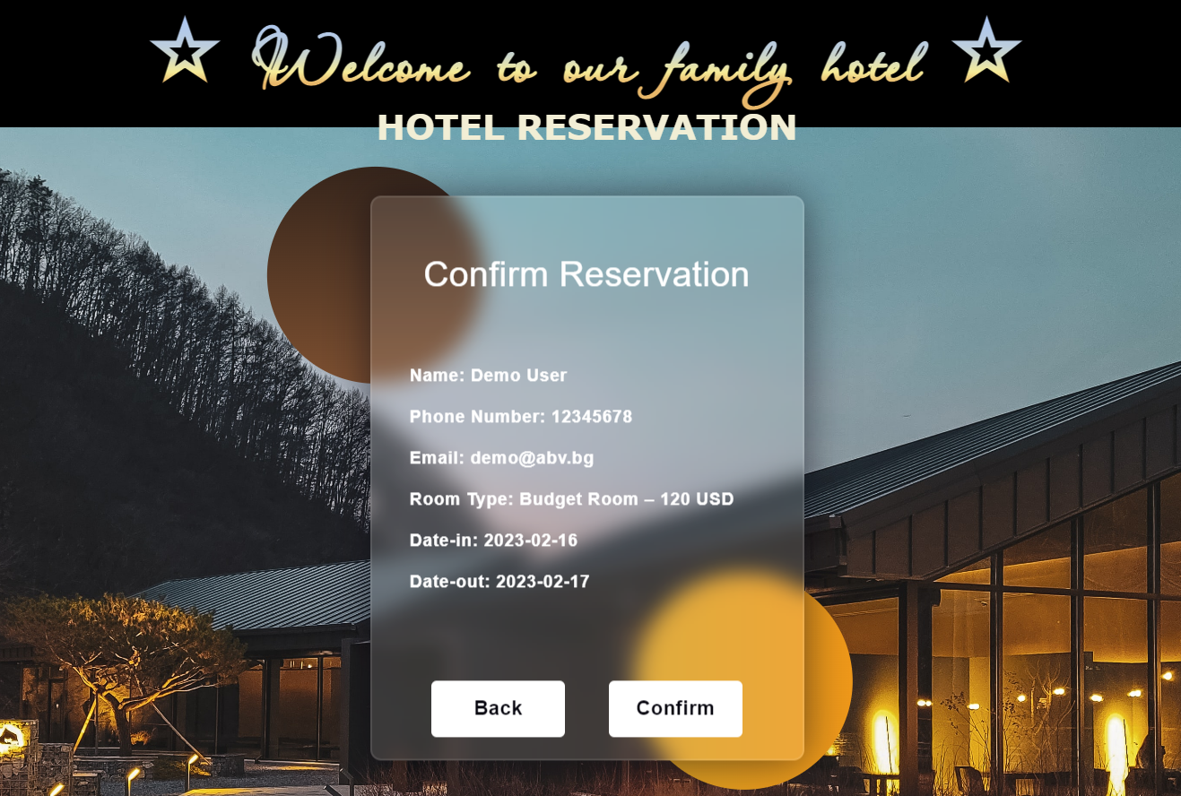

#### Step 1: Create the Repo

The **team** **leader** creates an **empty** **GitHub** **repo** and **add** the **files** from resources (**index**.**html**, **solution**.**js**, **static** **folder**).

#### Step 2: Invite the Team Members

The **team leader invites** the other team **members** as **collaborators** in the **new GitHub repo**.



An **email** **invitation** will be sent for each **invited** **collaborator**.

#### Step 3: Clone the Project

Each **team** **member** **clones** the project from the **team leader's GitHub repository** to a **local folder**:

|  |
| --- |
| git clone {GitHub repo URL} |

#### Step 4: Implement Project Functionalities

Each **team** **member** **implements** different **functionality locally** (each **member** has its **own document with instructions** in the provided **resources**).

* **Member #1**: **Questioner's** functionality (**Search Form**)
* **Member #2**: **Offerer's** functionality (**Our Offers Form**)
* **Member #3**: **Admin's** functionality (**Guest Details Form**)
* **Member #3**: **Verifier's** functionality (**Confirm Reservation Form**)

You should have a **separate branch** **in GitHub** for **each functionality**, e.g., **each member** should have a **branch of their own**.

##### Questioner

**Questioner** should implement the "**Search Form"** functionality:

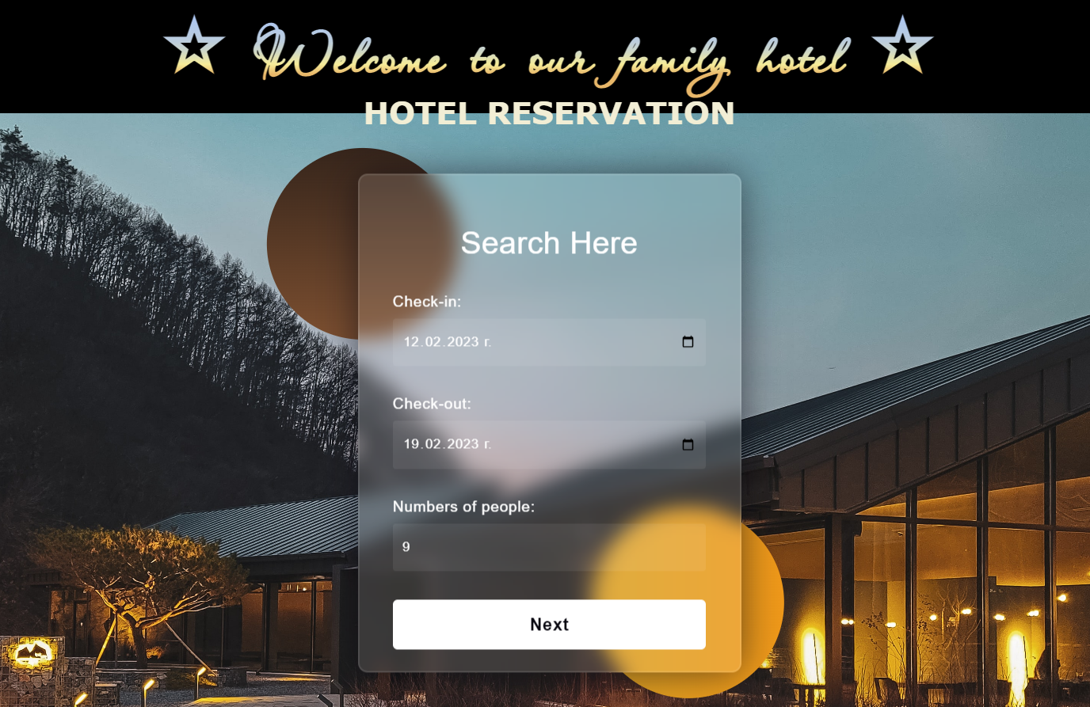

**Searched** **form** contains **information** about the **check-in date**, the **check-out date**, and the **numbers** of **people** accommodated.

**Questioner** **clones** the project repository, makes a sequence of **changes** in the source code files, **commits** locally in repository, then **pushes** the committed changes to GitHub.

###### Step 1: Clone the "Hotel Reservation" Repository

**Questioner** should already have cloned the repo.

###### Step 2: Create a Local Branch

We want to **add some new features** to our SPA app. We are working in our **local repository**, and we do not want to disturb or wreck the main project. So, we create a **new local branch**:

|  |
| --- |
| git branch search-form |

We have **two** **branches** now: **main** and **search**-**form**.

Now we should check out the **new** **branch**, e.g., switch from the **current** **branch** to the **new** **one**.

|  |
| --- |
| git checkout search-form |

We have moved our **current** **workspace** from the **main** **branch**, to the **search**-**form** **branch.**

###### Step 3: Search Form: HTML

In index.html, in **div** with **class** "**site**-**content**" they add some **HTML** (Questioner/index.html file from the resources) for the **search** **form**.

###### Step 4: Search Form: JavaScript Code

In solution.js, they adda a new function (Questioner/solution.js file from the resources) to the **search** **form**.

###### Step 5: Search Form: CSS

In styles.css, they add **styles** (Questioner/styles.css file from the resources) to the **search** **form**.

###### Step 6: Test the Project Functionality

**Questioner** now **tests the project functionality** to see whether SPA app works correctly, as well as whether the entire project works as expected:

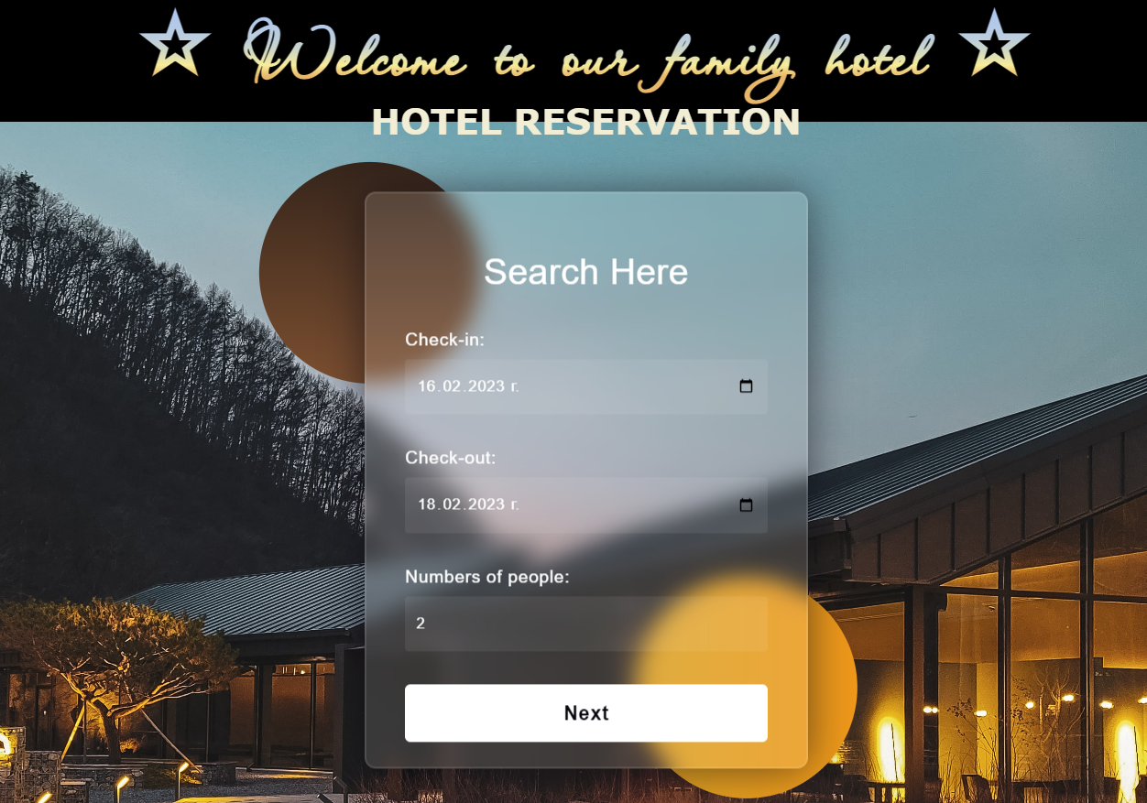

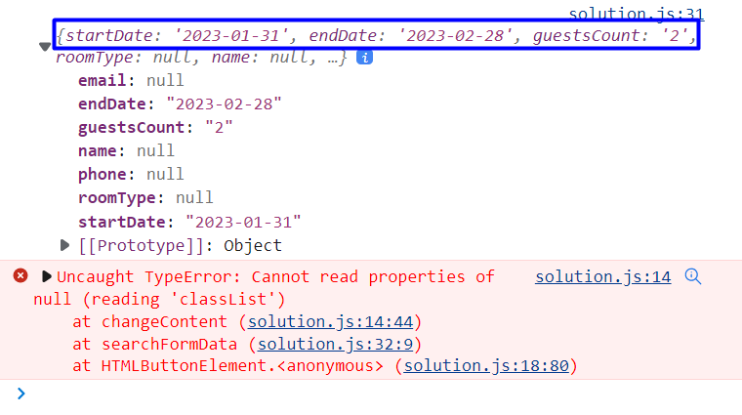

**Don't worry about the error!**

###### Step 7: Commit All Changes to the Local Branch

**Questioner adds** and **commits** in Git all **local changes**:

|  |
| --- |
| git commit -a -m "Implemented Search form functionality" |

Now we have a **new** **branch**, that is different from **main**. If we now **push** to the **repo**, we will get an **error** because the **search-form branch** is **local**, **not** **upstream**, e.g., it is **not** in **GitHub** yet, only **locally**:

|  |
| --- |
| git push |

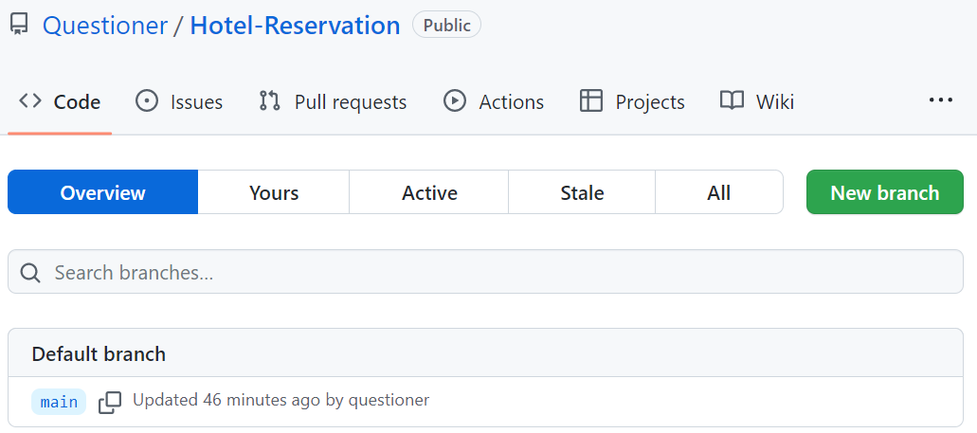

To fix this **error** we should run the **following** **command**.

|  |
| --- |
| git push --set-upstream origin search-form |

The "**--set-upstream**" option is **utilized** to **set** the **remote** as the **upstream** directory and **fix** the above-encountered error.

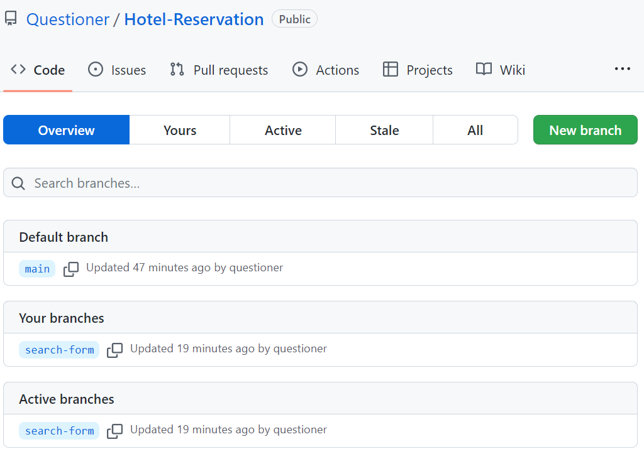

We have the **upstream** **branch** **search**-**form**.

###### Step 8: Create a Pull Request

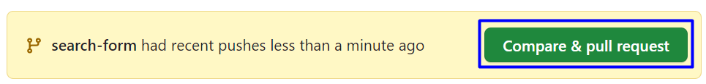

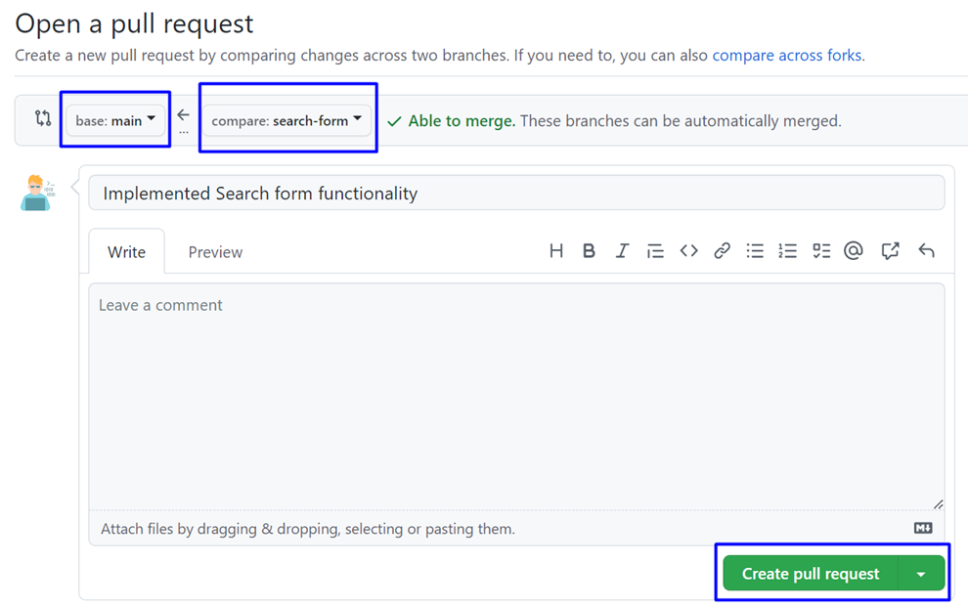

Don't forget to **add** a **reviewer**.

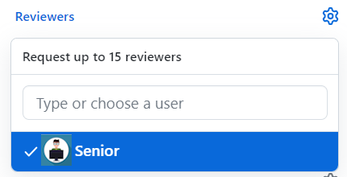

Add a **title** and **create the pull request**:

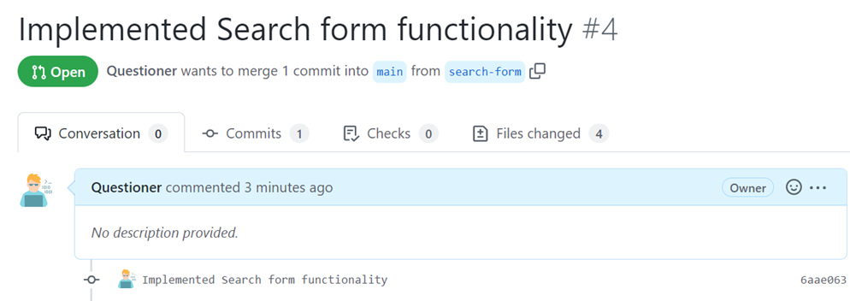

###### Step 9: Approve a Pull Request

Now you should **approve** one of your friend's **pull** **requests**. But before that, we should **resolve** the **conflicts**.

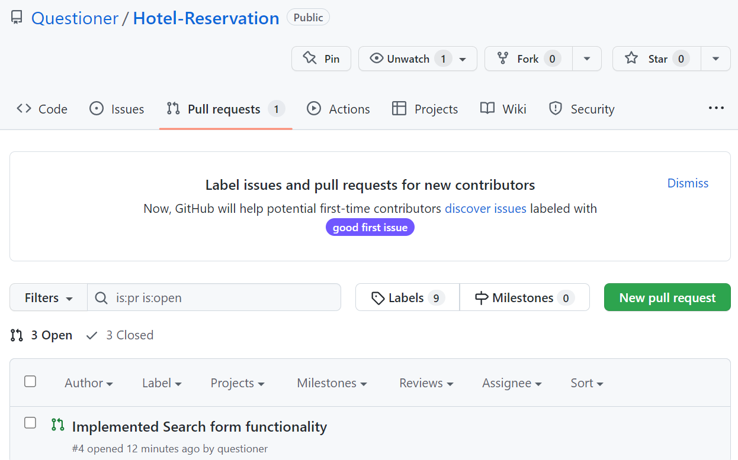

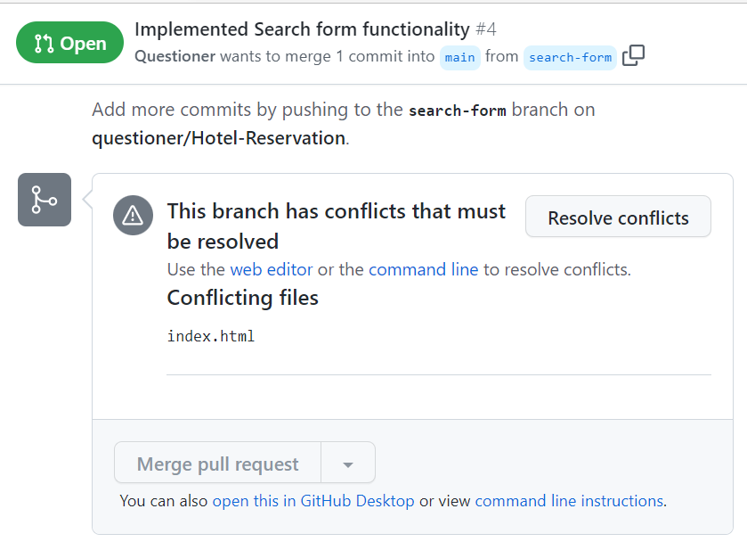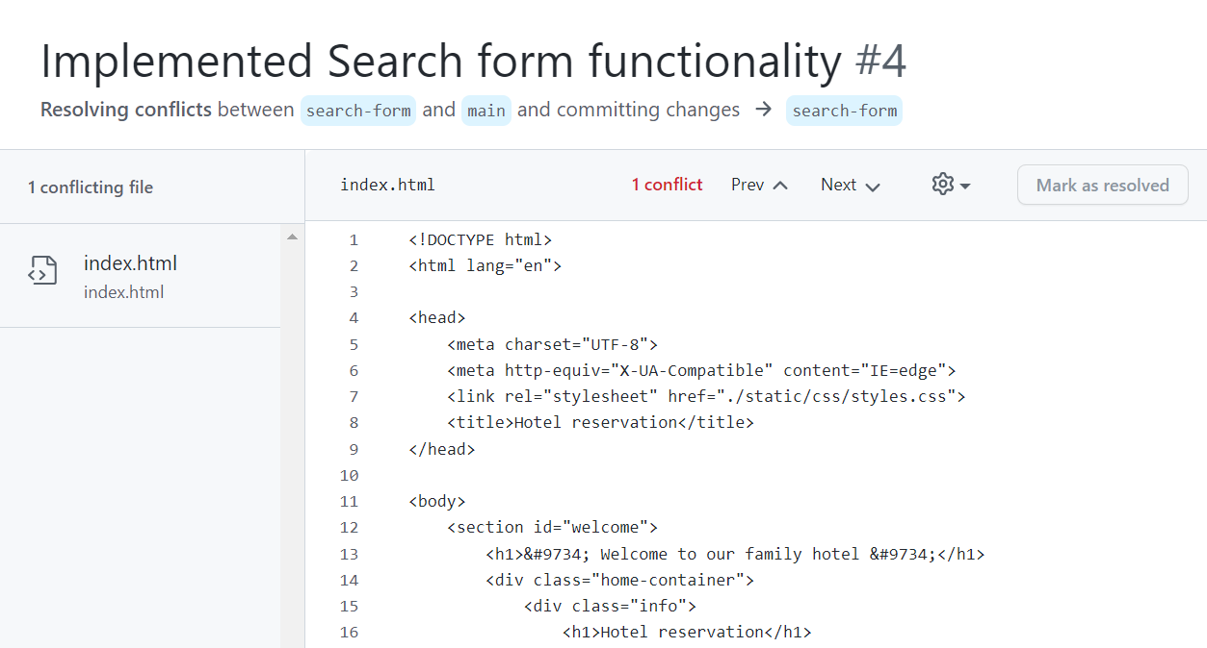

When **conflicts are resolved**, **merge the changes**:

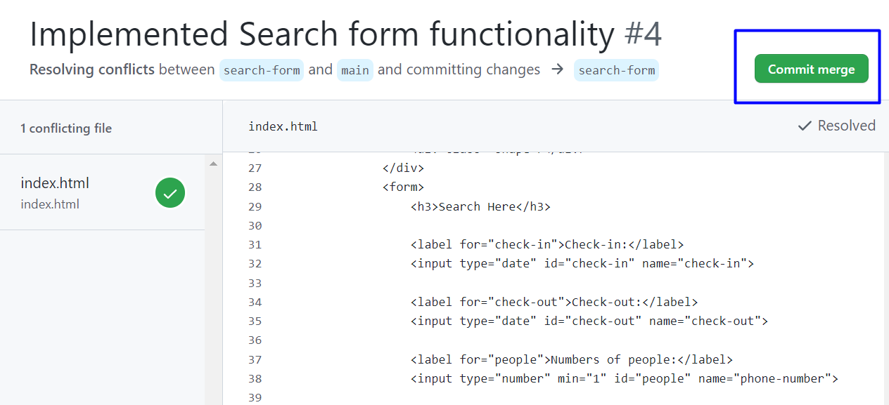

###### Step 10: Merge Pull Request

**Merge** the **search-form** branch into the **main** **branch.**

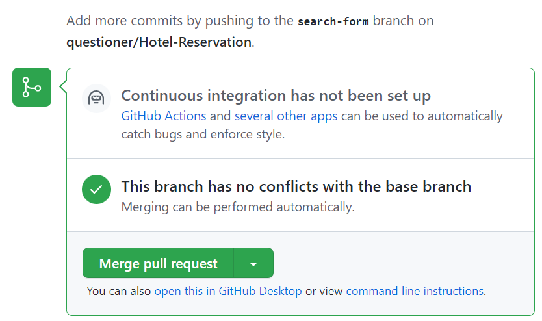

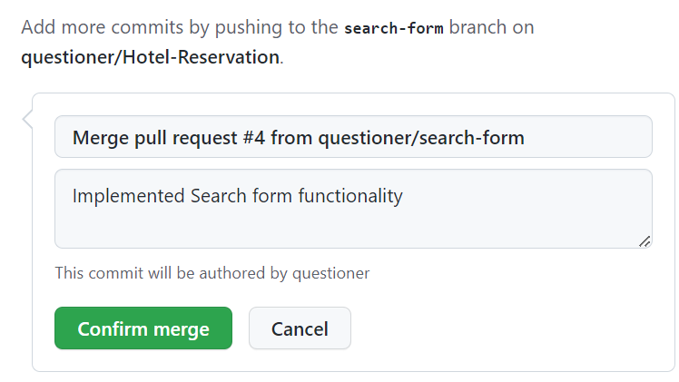

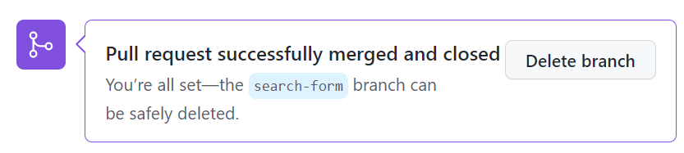

##### Offerer

**Offerer** should implement the "**Our Offers Form"** functionality:



The **purpose** of **Offerer** is to find out what kind of **room** our **client** **prefers**.

Offerer **clones** the project repository, makes a sequence of **changes** in the source code files, **commits** locally in his repository, then **pushes** the committed changes to GitHub.

###### Step 1: Clone the "Hotel Reservation" Repository

**Offerer** should already have cloned the repo.

###### Step 2: Create a Local Branch

We want to **add some new features** to our SPA app. We are working in our **local repository**, and we do not want to disturb or wreck the main project. So, we create a **new local branch**:

|  |
| --- |
| git branch our-offers-form |

We have **two** **branches** now: **main** and **our-offers-form**.

Now we should check out the **new** **branch**, e.g., switch from the **current** **branch** to the **new** **one**.

|  |
| --- |
| git checkout our-offers-form |

We have moved our **current** **workspace** from the **main** **branch**, to the **our-offers-form** **branch.**

###### Step 3: Search Form: HTML

In index.html, in **div** with **class** "**site**-**content**" he adds some **HTML** (Offerer/index.html file from the resources) for the offers form.

###### Step 4: Search Form: JavaScript Code

In solution.js, they add a new function (Offerer/solution.js file from the resources) to the **offers** **form**.

Use this **code** **box** only **while** **testing** **functionality** in your **custom** **branch**.

|  |
| --- |
| changeContent('search-result-form-content'); |

###### Step 5: Search Form: CSS

In styles.css, they add **styles** (Offerer/styles.css file from the resources) to the **offers** **form**.

###### Step 6: Test the Project Functionality

**Offerer** now **tests the project functionality** to see whether SPA app works correctly, as well as whether the entire project works as expected:

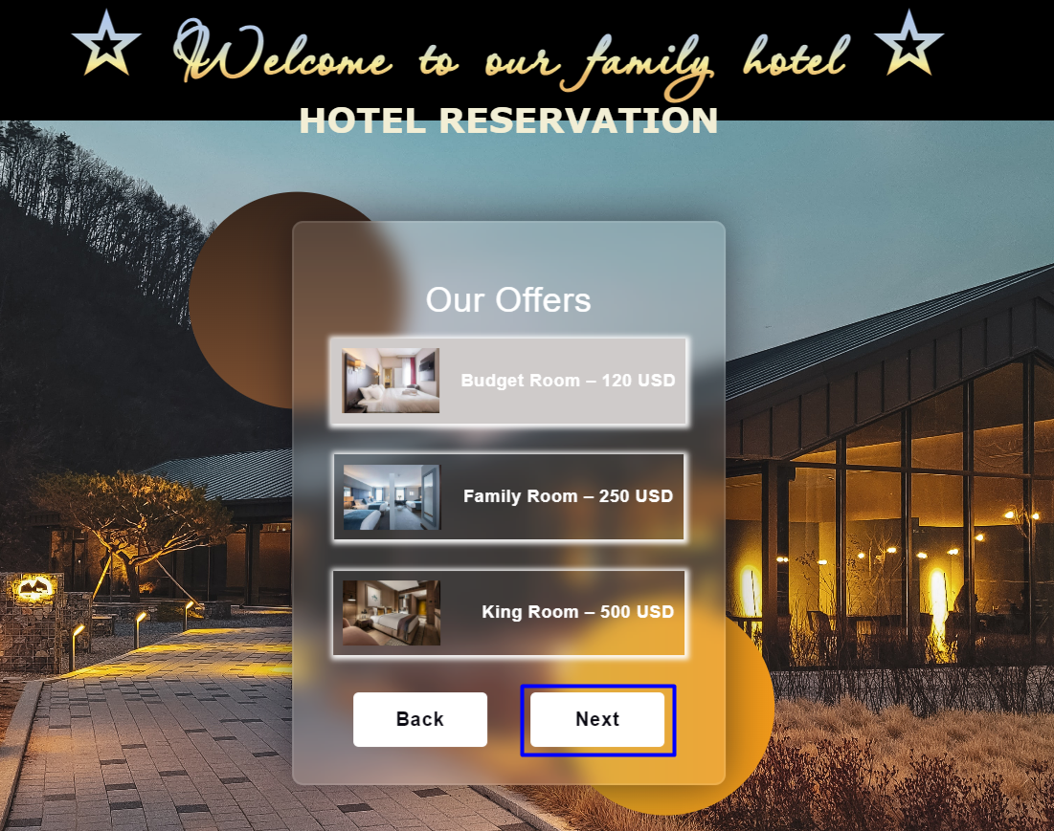

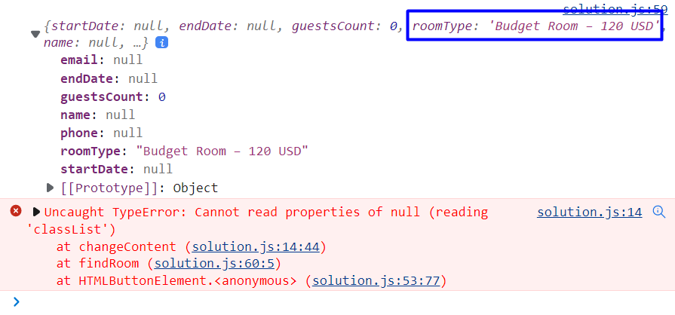

**Don't worry about the error!**

###### Step 7: Commit All Changes to the Local Branch

**Offerer adds** and **commits** in Git all **local changes**:

|  |
| --- |
| git commit -a -m "Implemented Our Offers form functionality" |

Now we have a **new** **branch**, that is different from **main**. If we now **push** to the **repo**, we will get an **error** because the **our-offers-branch branch** is **local**, **not** **upstream**, e.g., it is **not** in **GitHub** yet, only **locally**:

|  |
| --- |
| git push |

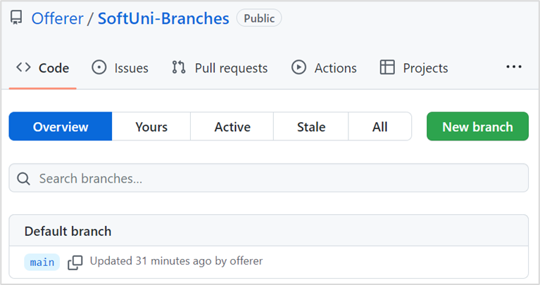

To fix this **error** we should run the **following** **command**.

|  |
| --- |
| git push --set-upstream origin our-offers-form |

The "**--set-upstream**" option is **utilized** to **set** the **remote** as the **upstream** directory and **fix** the above-encountered error.

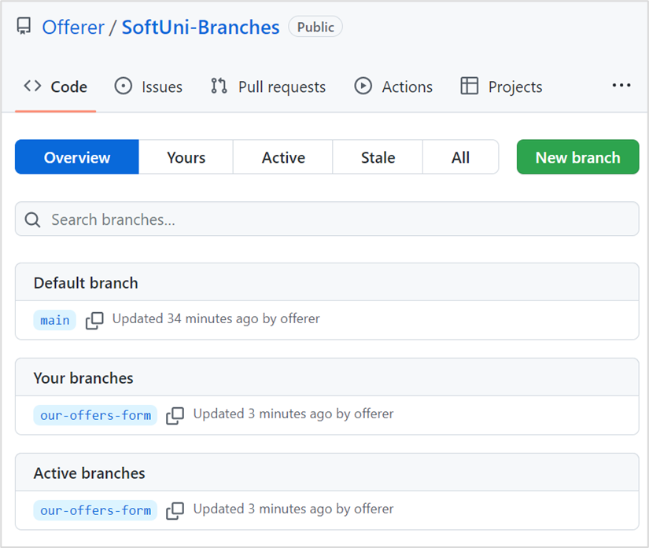

We have the **upstream** **branch** **our-offers**-**form**.

###### Step 8: Create a Pull Request

Now go to your **GitHub** **repo** and **create** a **pull** **request** for merge from the **our-offers-form to the main branch**:

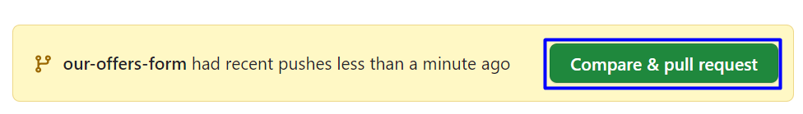

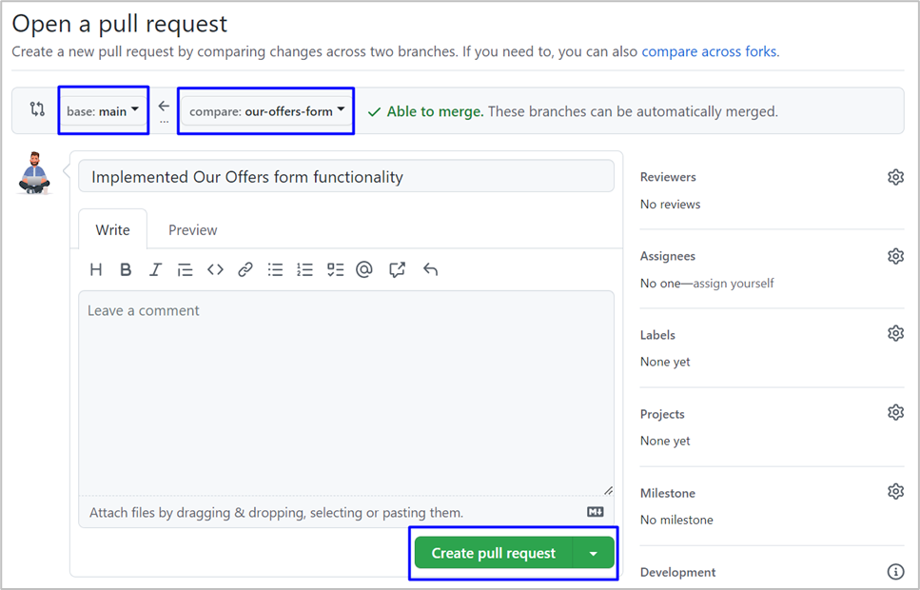

Don't forget to **add** a **reviewer**.



Add a **title** and **create the pull request**:

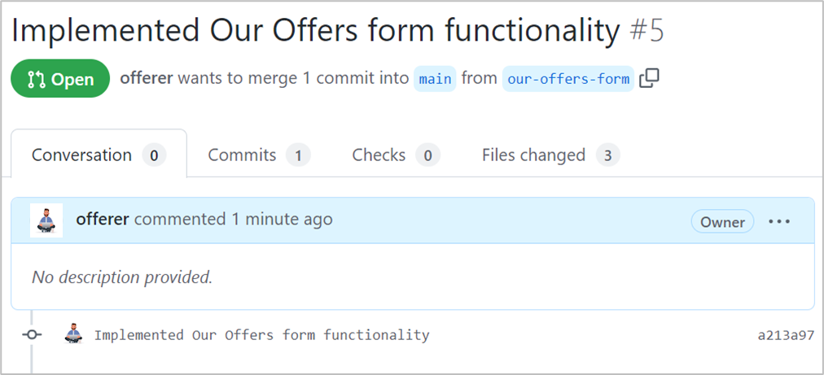

###### Step 9: Approve a Pull Request

Now you should **approve** one of your friend's **pull** **requests**. But before that, we should **resolve** the **conflicts**.





When **conflicts are resolved**, **merge the changes**:



###### Step 10: Merge Pull Request

**Merge** the **search-form** branch into the **main** **branch.**





##### Admin

The **Admin** should implement the "**Guest Details Form"** functionality:

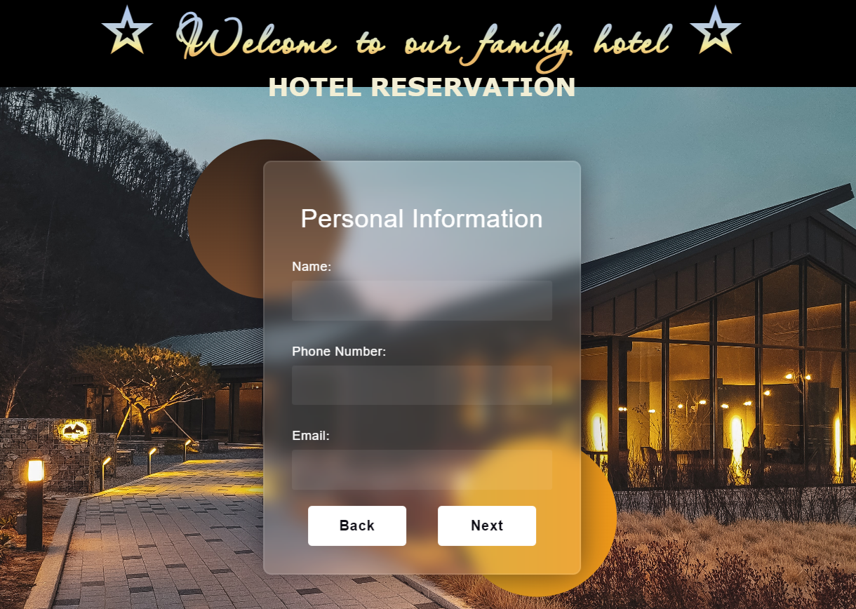

The **Admin's task** is to **collect** and **store** the **data** for each **person** (**name**, **phone number** and **email**).

The **Admin clones** the project repository, makes a sequence of **changes** in the source code files, **commits** locally in repository, then **pushes** the committed changes to GitHub.

###### Step 1: Clone the "Hotel Reservation" Repository

The **Admin** should already have **cloned** **locally** the **main** **project** **repo**.

###### Step 2: Create a Local Branch

We want to **add some new features** to our SPA app. We are working in our **local repository**, and we do not want to disturb or wreck the main project. So, we create a **new local branch**:

|  |
| --- |
| git branch guest-details-form |

We have **two** **branches** now: main and guest-details-form.

Now we should check out the **new** **branch**, e.g., switch from the **current** **branch** to the **new** **one**.

|  |
| --- |
| git checkout guest-details-form |

We have moved our **current** **workspace** from the main **branch**, to the guest-details-form **branch.**

###### Step 3: Search Form: HTML

In index.html, in **div** with **class** "site-content" he adds some **HTML** (Admin/index.html file from the resources) for the **guest** **details form**.

###### Step 4: Search Form: JavaScript Code

In solution.js, they add a new function (Admin/solution.js file from the resources) to the **guest details** **form**.

Use this **code** **box** only **while** **testing** **functionality** in your **custom** **branch**.

|  |
| --- |
| changeContent('guest-details-form-content'); |

###### Step 5: Search Form: CSS

In styles.css, they add **styles** (Admin/styles.css file from the resources) to the **guest details** **form**.

###### Step 6: Test the Project Functionality

The **Admin** now **tests the project functionality** to see whether SPA app works correctly, as well as whether the entire project works as expected:

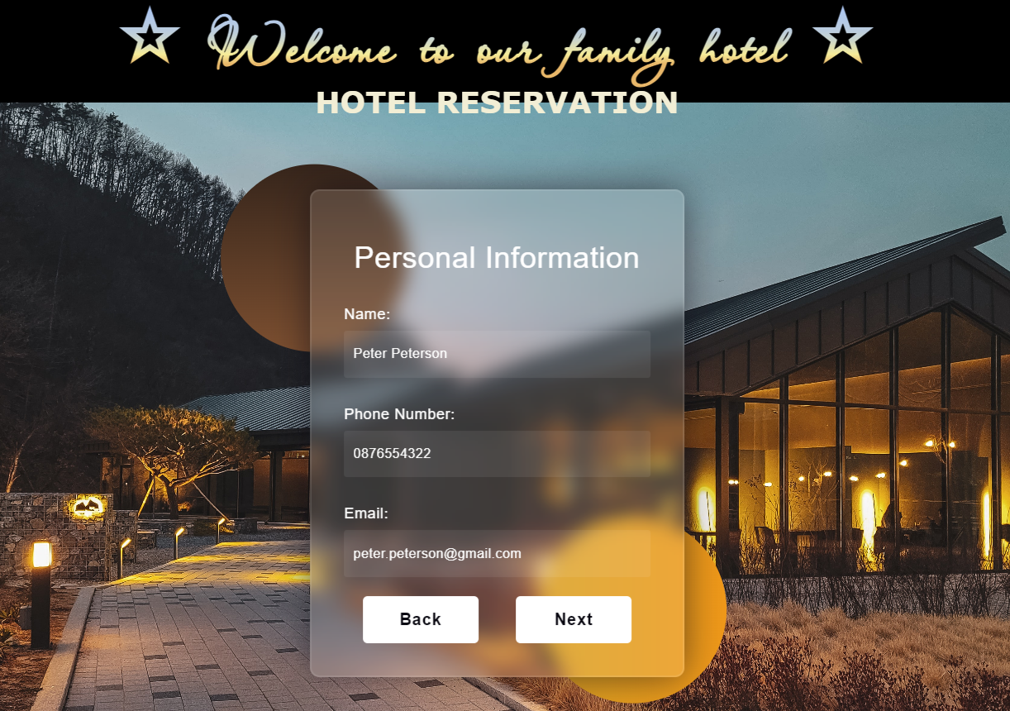

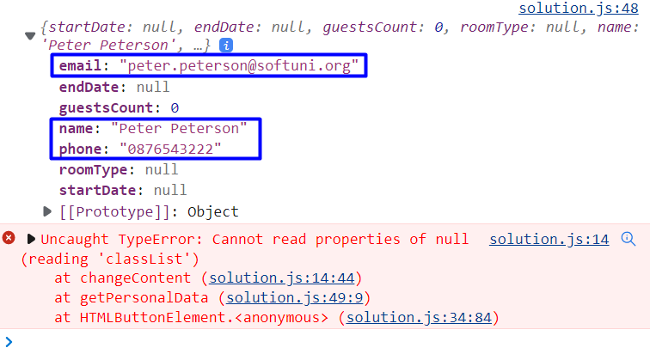

**Don't worry about the error!**

###### Step 7: Commit All Changes to the Local Branch

The **Admin adds** and **commits** in Git all **local changes**:

|  |
| --- |
| git commit -a -m "Implemented Guest Details form functionality" |

Now we have a **new** **branch**, that is different from main. If we now **push** to the **repo**, we will get an **error** because the guest-details-form **branch** is **local**, **not** **upstream**, e.g., it is **not** in **GitHub** yet, only **locally**:

|  |
| --- |
| git push |

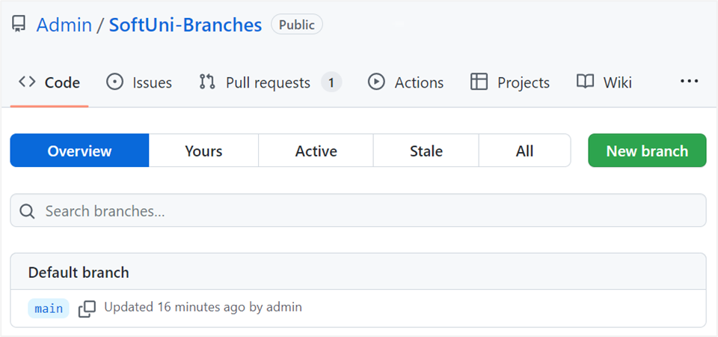

To fix this **error** we should run the **following** **command**.

|  |
| --- |
| git push --set-upstream origin guest-details-form |

The "--set-upstream" option is **utilized** to **set** the **remote** as the **upstream** directory and **fix** the above-encountered error.

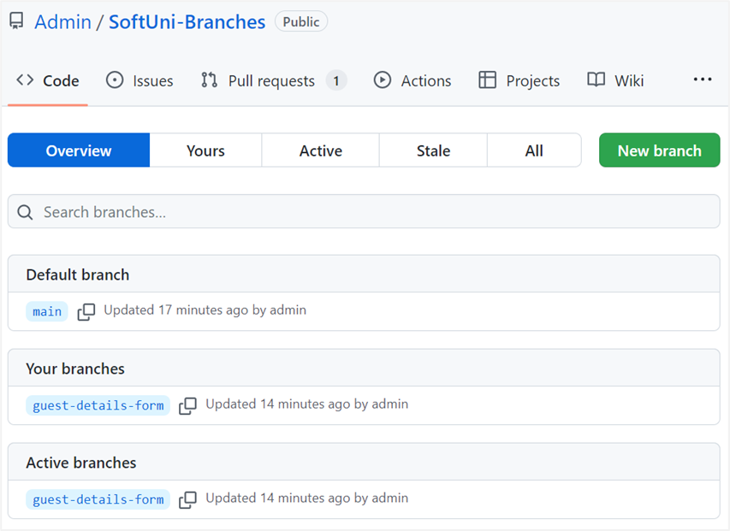

We have the **upstream** **branch** guest-details-form.

###### Step 8: Create a Pull Request

Now go to your **GitHub** **repo** and **create** a **pull** **request** for merge from the guest-details-form **to the** main **branch**:

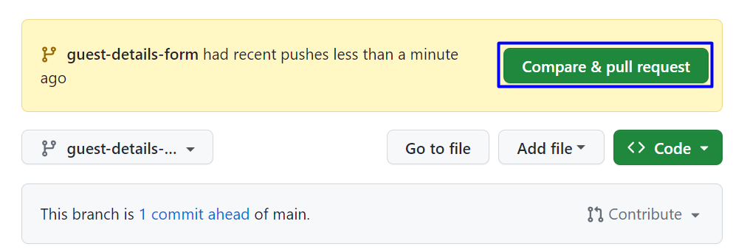

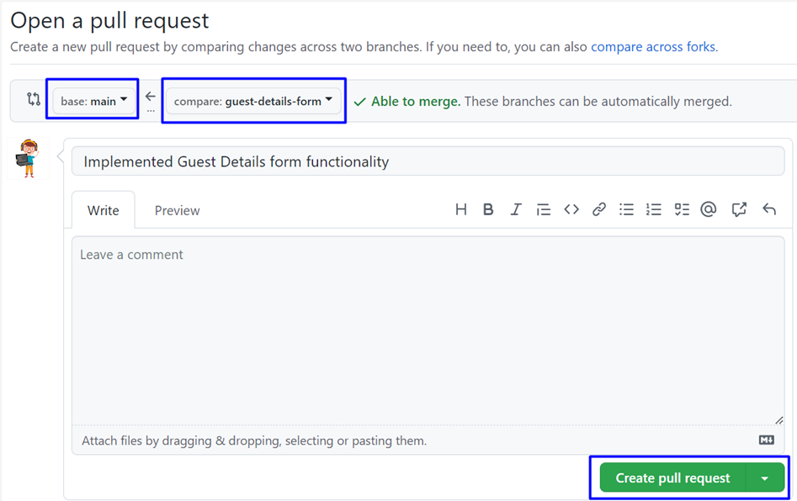

Don't forget to **add** a **reviewer**.



###### Step 9: Approve a Pull Request

Now you should **approve** one of your friend's **pull** **requests**. But before that, we should **resolve** the **conflicts**.





When **conflicts are resolved**, **merge the changes**:



###### Step 10: Merge Pull Request

**Merge** the **search-form** branch into the **main** **branch.**

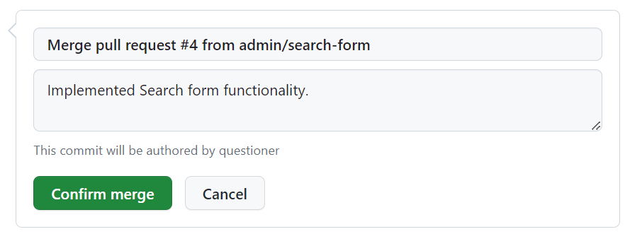



##### Verifier

**Verifier** should implement the "**Confirm Reservation Form"** functionality:

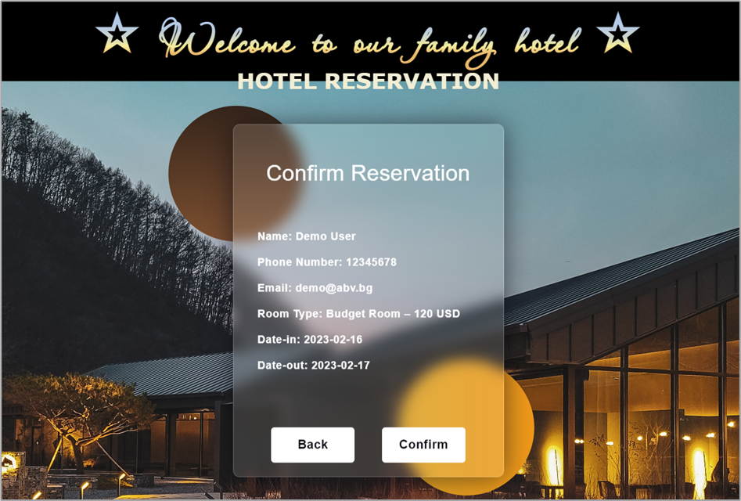

The **Verifier's task** is to **confirm personal data.**

**Verifier clones** the project repository, makes a sequence of **changes** in the source code files, **commits** locally in repository, then **pushes** the committed changes to GitHub.

###### Step 1: Clone the "Hotel Reservation" Repository

The **Verifier** should already have **cloned** **locally** the **main** **project** **repo**.

###### Step 2: Create a Local Branch

We want to **add some new features** to our SPA app. We are working in our **local repository**, and we do not want to disturb or wreck the main project. So, we create a **new local branch**:

|  |
| --- |
| git branch confirm-reservation-form |

We have **two** **branches** now: **main** and **confirm-reservation-form**.

Now we should check out the **new** **branch**, e.g., switch from the **current** **branch** to the **new** **one**.

|  |
| --- |
| git checkout confirm-reservation-form |

We have moved our **current** **workspace** from the **main** **branch**, to the **confirm-reservation-form branch.**

###### Step 3: Search Form: HTML

In index.html, in **div** with **class** "**site**-**content**" he adds some **HTML** (Verifier/index.htmlfile from the resources) for the **confirm** **reservation form**.

###### Step 4: Search Form: JavaScript Code

In solution.js, he adds a new function (Verifier/solution.jsfile from the resources) to the **confirm** **reservation form**.

Use this **code** **box** only **while** **testing** **functionality** in your **custom** **branch**.

|  |
| --- |
| changeContent('confirm-reservation-content'); |

###### Step 5: Search Form: CSS

In styles.css, he adds **styles** (Verifier/styles.cssfile from the resources) to the **confirm** **reservation form**.

###### Step 6: Test the Project Functionality

**Verifier** now **tests the project functionality** to see whether SPA app works correctly, as well as whether the entire project works as expected:

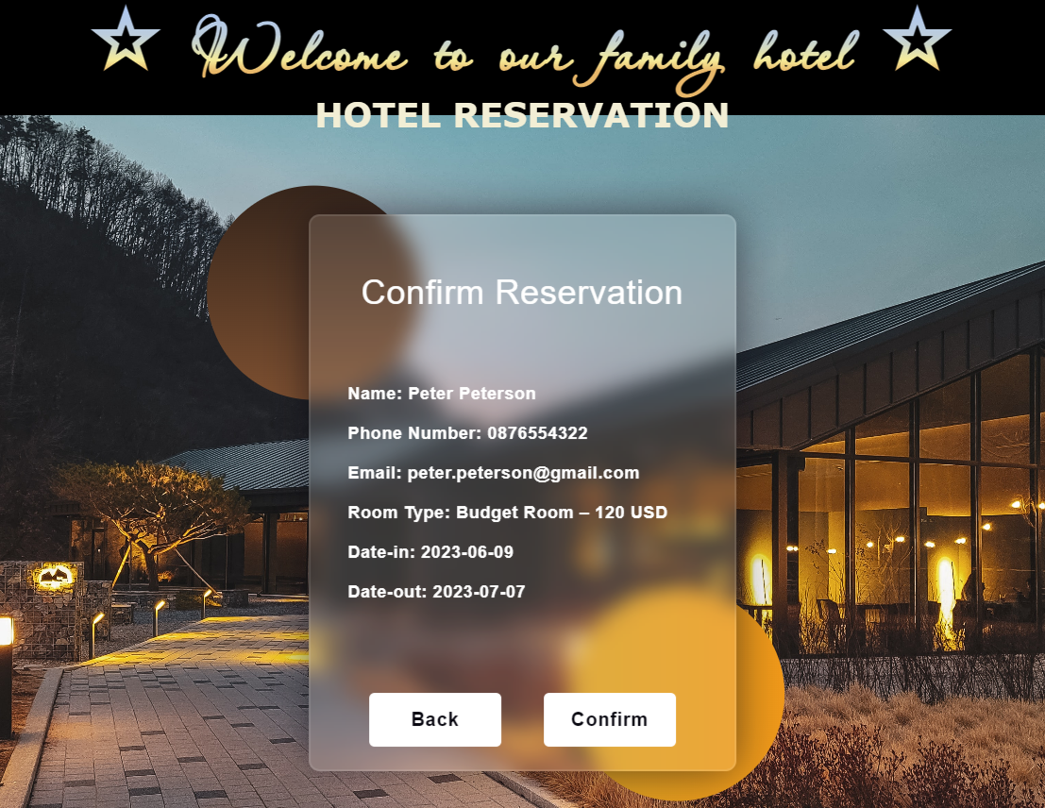

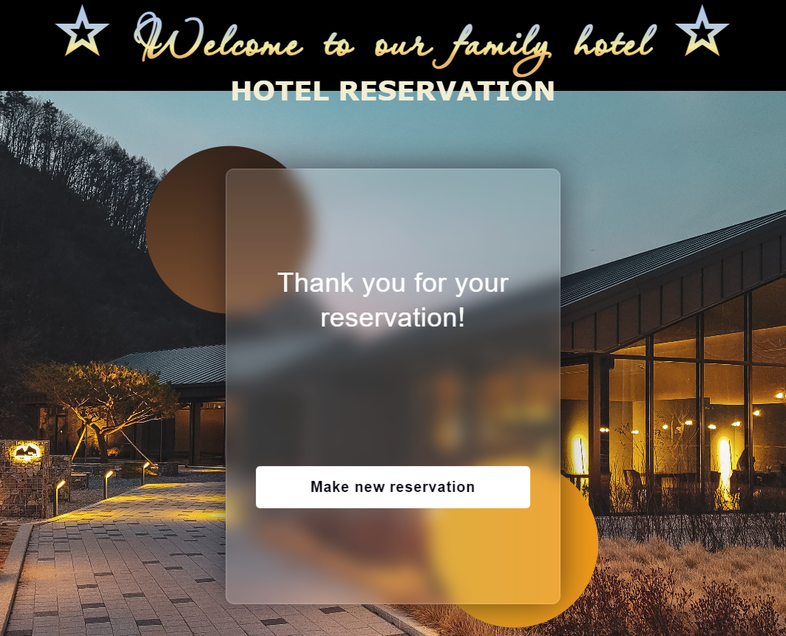

###### Step 7: Commit All Changes to the Local Branch

**Verifier adds** and **commits** in Git all **local changes**:

|  |
| --- |
| git commit -a -m "Implemented Confirm Reservation form functionality" |

Now we have a **new** **branch**, that is different from **main**. If we now **push** to the **repo**, we will get an **error** because the **confirm-reservation-form branch** is **local**, **not** **upstream**, e.g., it is **not** in **GitHub** yet, only **locally**:

|  |
| --- |
| git push |

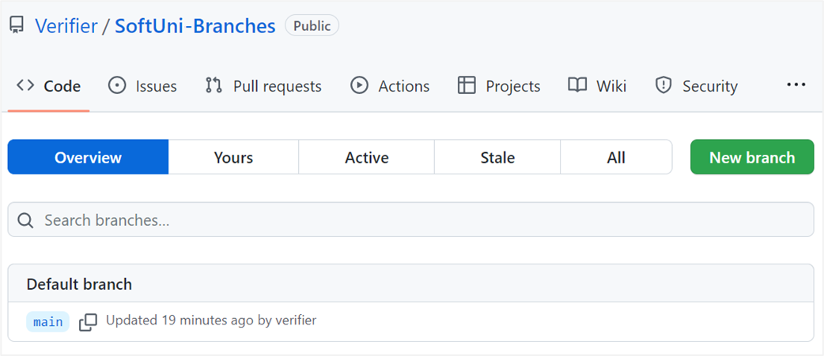

To fix this **error** we should run the **following** **command**.

|  |
| --- |
| git push --set-upstream origin confirm-reservation-form |

The "**--set-upstream**" option is **utilized** to **set** the **remote** as the **upstream** directory and **fix** the above-encountered error.

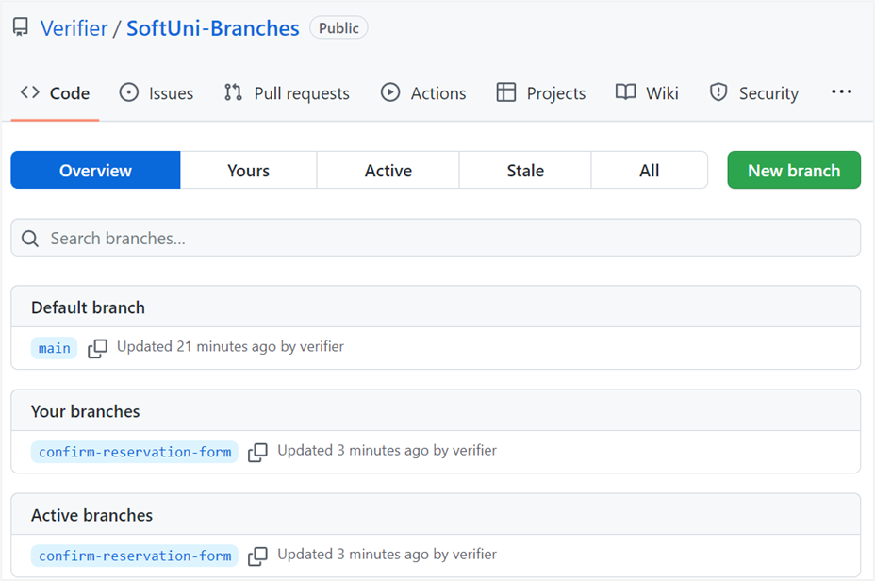

We have the **upstream** **branch** **confirm**-**reservation**-**form**.

###### Step 8: Create a Pull Request

Now go to your **GitHub** **repo** and **create** a **pull** **request** for merge from the **confirm**-**reservation**-**form to the main branch**:

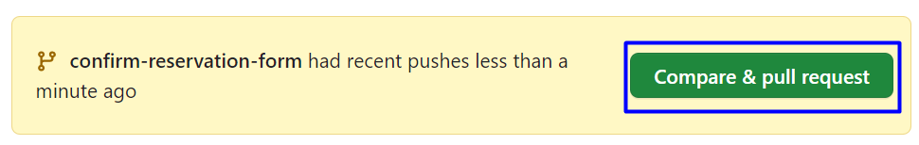

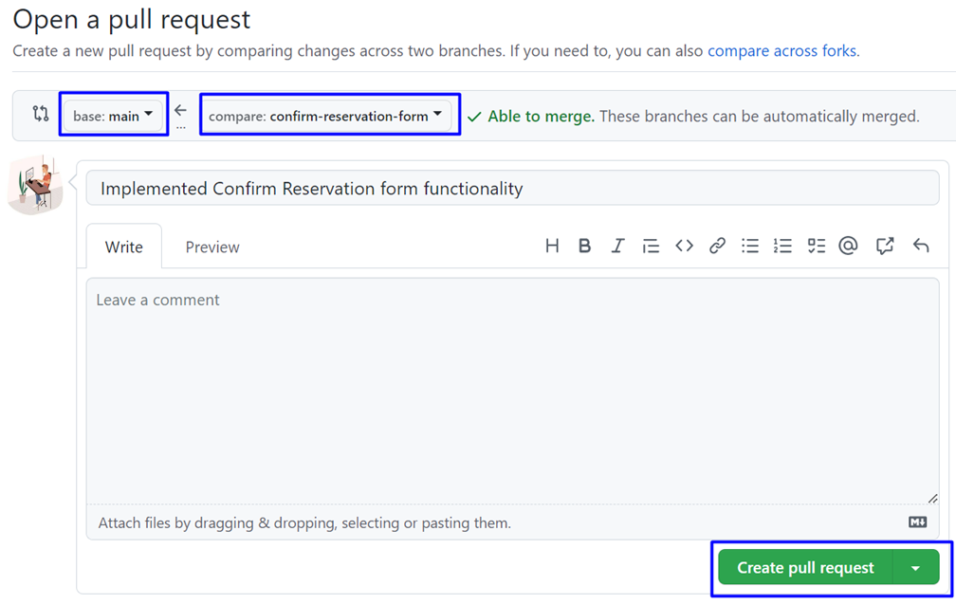

Don't forget to **add** a **reviewer**.



Add a **title** and **create the pull request**:

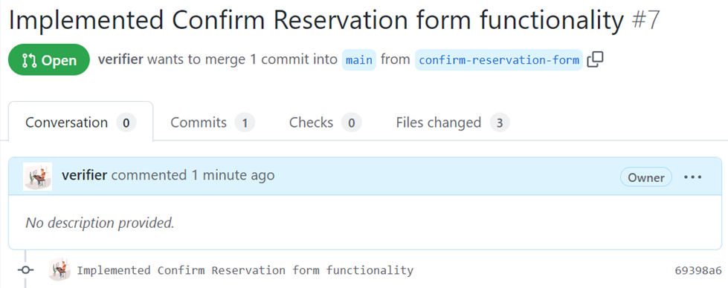

###### Step 9: Approve a Pull Request

Now you should **approve** one of your friend’s **pull** **requests**. But before that, we should **resolve** the **conflicts**.





When **conflicts are resolved**, **merge the changes**:



###### Step 10: Merge Pull Request

**Merge** the **search-form** branch into the **main** **branch.**



#### Step 5: Merge and Create / Approve Pull Requests

When done with their functionalities, each team member should **merge their feature branch** into the main **branch** of the **GitHub** **repo**.

* Each team member should **create** a **pull** **request**. When the **pull request is approved** and the **branch is successfully merged**, they should **delete the feature branch**.
* Each team member should **accept** **one** **pull** **request of another collaborator**.

You should also **solve conflicts** that **appear on merge**. At the end, all **pull requests should be approved** and **all feature branches** should be **merged** **into** main and **deleted**.